**Team id: PNT2022TMID50173**

**Sending Alert Message**

pip install pygobject

Looking in indexes: https://pypi.org/simple, https://us-python.pkg.dev/colab-wheels/public/simple/

Requirement already satisfied: pygobject in /usr/lib/python3/dist-packages (3.26.1)

**from** matplotlib **import** pyplot **as** plt

*#import load model from keras.model*

**from** keras.models **import** load_model

*#import image from keras*

**from** tensorflow.keras.preprocessing **import** image

img1 **=** image**.**load_img('/content/drive/MyDrive/Dataset/test_set/with fire/Wild_fires.jpg',target_size**=**(128,128))

Y **=** image**.**img_to_array(img1)

x **=** np**.**expand_dims(Y,axis**=**0)

val **=** model**.**predict(x)

plt**.**imshow(img)

plt**.**show()

**if** val**==**1:

print('Forest fire')

1/1 [==============================] - 0s 32ms/step

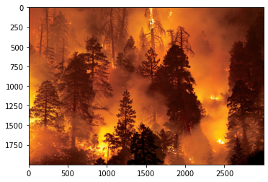

Forest fire

**if** val**==**1:

print('Forest fire')

**from** twilio.rest **import** Client

print('Forest fire')

account_sid**=**'ACfb4e6d0e7b0d25def63044919f1b96e3'

auth_token**=**'f9ae4fc4a617a527da8672e97eefb2d8'

client**=**Client(account_sid,auth_token)

message**=**client**.**messages \

**.**create(

body**=**'forest fire is detected,stay alert',

*#use twilio free number*

from_**=**'+1 302 248 4366',

*#to number*

to**=**'+91 99400 12164')

print(message**.**sid)

print("Fire detected")

print("SMS Sent!")

**elif** val**==**0:

print('No Fire')

Forest fire

Forest fire

SMecc097520dc517b33e614c710d406781

Fire detected

SMS Sent!